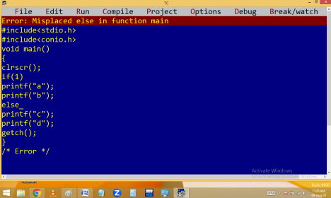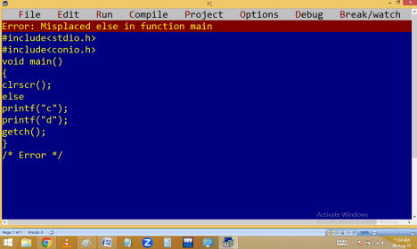
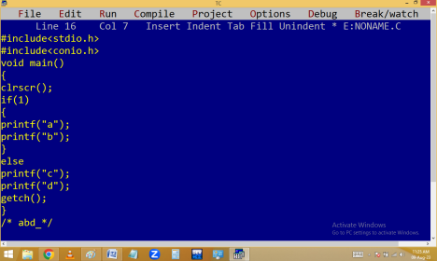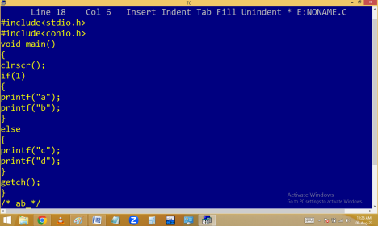
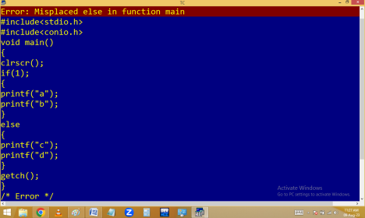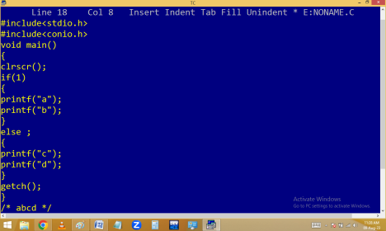
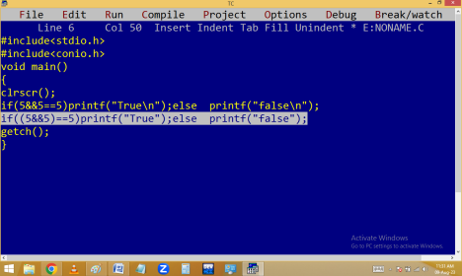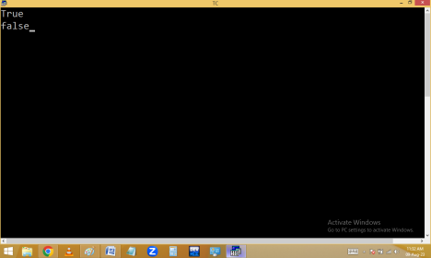
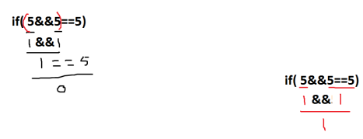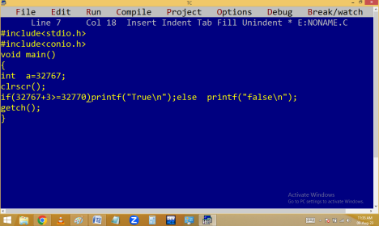
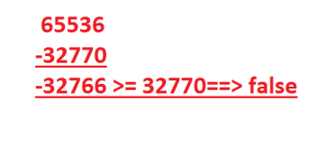
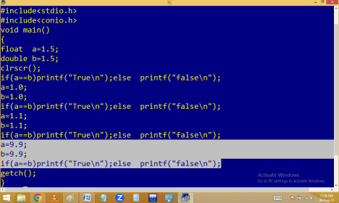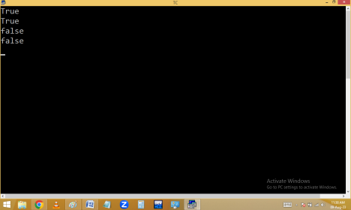
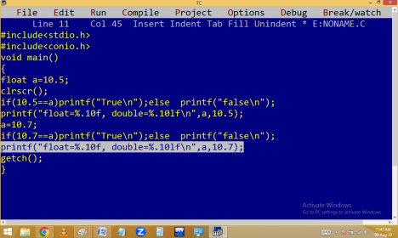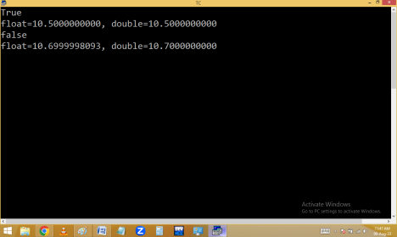
if…else if / ladder if
When the program contain 3 or more options and user have to select 1 then go for if else if ladder. In if..else if the conditions are tested from top to bottom one by one like the ladder steps and any one condition is true then statements in that if block are executed and program execution jumped to outside the if series. If no condition true then statements in else are executed. Here else is optional.
Finding +Ve / -Ve / 0
Finding no of days in given month.
1,3,5,7,8,10,12 – 31 days
2 – 28/29 days
4,6,9,11 – 30 days
Others – invalid month
Finding max in 2 numbers.
Finding max in 3 numbers.
Home work:
Read a character and find out it is lower / upper / digit / space / special character.

